Face Recognition Dataset Report
Tasks 1 to 8

Task 1 — Dataset Structure & Configuration

1. Why is the unknown class important?
The unknown class is important because the system should be able to distinguish registered friends from people who are not in the known classes. Without an unknown class, the model may be forced to classify an unfamiliar person as one of the known friends.

2. Dataset structure
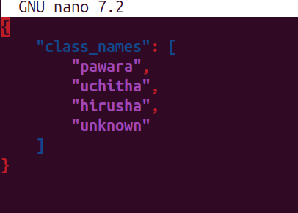

Class mapping:

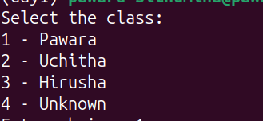

3. config.json
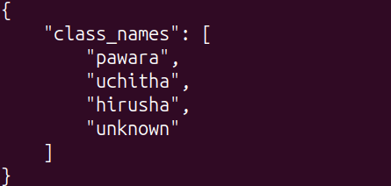

4. Why is class order important?
Class order is important because each class is assigned a numerical label. The same class-to-label mapping must be used during dataset creation, training, validation and prediction. If the order changes, the numerical labels may represent different people and the model predictions can be interpreted incorrectly.

Task 2 — Face Data Collection

1. Capture process
OpenCV was used to capture face images from a webcam. A Haar Cascade classifier was used to detect faces. When a face was detected, a rectangle was drawn around it. Pressing the Space key captured the cropped face with 20% padding and saved it using a timestamp-based filename. Pressing q stopped the capture process.
Script: scripts/capture.py

2. Data collection log

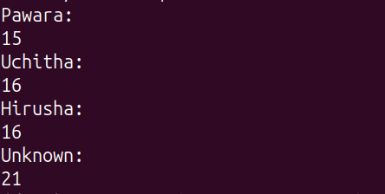

3. scaleFactor
scaleFactor controls how much the image size is reduced between detection stages. A smaller value searches at more scales and can improve detection but takes more time. A larger value is faster but may miss some faces.

4. minNeighbors
minNeighbors controls how many nearby detections are required before a region is considered a face. Increasing it reduces false detections but may miss some faces. Decreasing it detects more faces but can produce more false positives.

5. Three raw-image problems
- Poor or uneven lighting.
- Motion blur or camera blur.
- Different face poses or partial occlusion.

Task 3 — Data Augmentation

1. Augmentations used
Augmentation | Purpose
Horizontal Flip | Simulates mirrored face orientation
Rotation | Simulates small head tilts
Brightness | Simulates different lighting
Contrast | Simulates camera/exposure differences
Gaussian Blur | Simulates motion or focus blur
Perspective | Simulates changes in viewing angle

3. Most realistic augmentation
Horizontal flipping and small rotations appeared to be the most realistic because these changes can naturally occur when a person's face is viewed from slightly different orientations.

4. Least realistic augmentation
Perspective transformation was the least realistic when the distortion became too strong because it produced face shapes that are unlikely to occur naturally in normal camera conditions.

5. Augmentation calculation
Given: 12 original images per person, 6 augmentations per original, 4 classes.
Per class: 12 × 6 = 72 images
Total: 72 × 4 = 288 images

6. Augmentation factor risks
Too low: The model may not receive enough variation and could overfit to the original training images.
Too high: Excessive augmentation can create unrealistic samples and may increase training time and storage requirements.

Task 4 — Train/Validation Split

1. Splitting method
The dataset was split into 80% training and 20% validation data using a fixed random seed of 42. Stratification was used to maintain approximately the same class proportions in both sets.

2. Our actual dataset
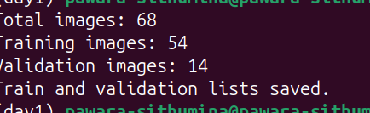

3. Why validation data isn't augmented
Validation data should represent the real data distribution used for evaluation. Random augmentation could make the validation results inconsistent and make it difficult to measure the actual performance of the model. Resizing and normalization are acceptable because they are preprocessing operations rather than random data augmentation.

4. Smile vs neutral problem
If all smiling images were placed in the training set and all neutral images in the validation set, the model could learn expression-specific patterns instead of facial identity. To avoid this, different expressions and poses should be distributed across both training and validation sets.

Task 5 — Build .pt Dataset

1. Dataset creation
The original training images were loaded and each training image was randomly augmented six times. The resulting images were resized to 224×224 and converted into PyTorch tensors. Validation images were resized to 224×224 and converted to tensors without random augmentation.

2. Actual output

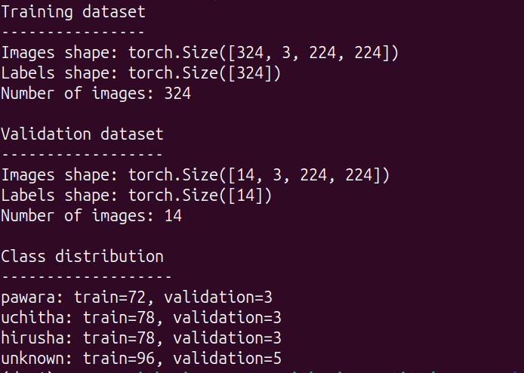

3.

Memory calculation
Image shape = 3 × 224 × 224; data type = float32; bytes per float = 4.
Memory per image = 3 × 224 × 224 × 4 = 602,112 bytes ≈ 0.574 MiB
Training dataset = 324 × 602,112 = 195,084,288 bytes ≈ 186.05 MiB

4. Why .pt instead of JPEG?
.pt files can store tensors and labels together and can be loaded directly by PyTorch. This avoids repeatedly converting JPEG images into tensors during training. However, .pt files can require more storage, are less convenient to inspect manually, and are mainly designed for PyTorch workflows.

Task 6 — Dataset Analysis

1. Dataset shapes

Training: [324, 3, 224, 224]
Validation: [14, 3, 224, 224]

2. Class distribution chart

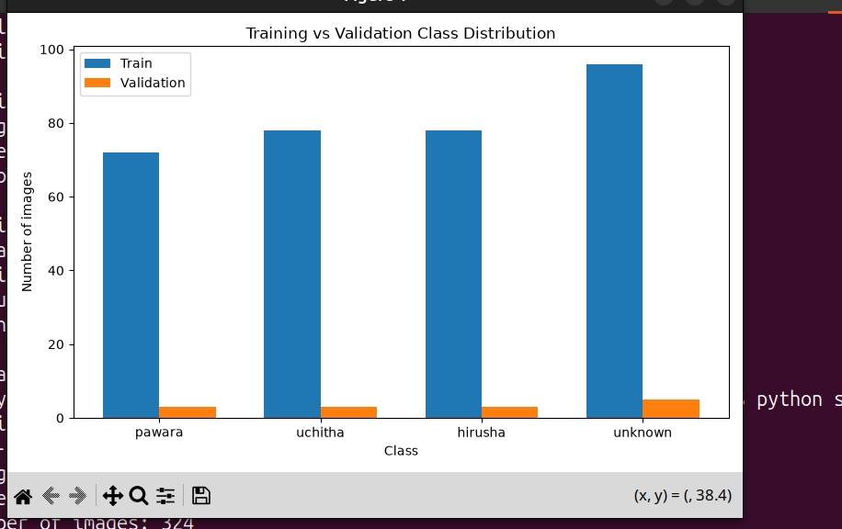

3. Random image grid
random_16_train_images.png is the evidence for this task. Because it contains face images, include it in the final submission only if the instructor's rules allow it; otherwise keep it locally.

4. Is the dataset balanced?
The dataset is not perfectly balanced. The unknown class contains more samples than the three friend classes. After augmentation, the training distribution is 72, 78, 78 and 96 samples respectively. The difference is not extremely large, but the model could still become slightly biased toward the class with more samples.

5. Why store paths?
The paths field stores the source path of each image. It is useful for tracing a tensor back to the original image when debugging incorrect labels, investigating misclassified samples, or checking problematic training examples.

Task 7 — Dataset & DataLoader

1. Dataset class
Script: scripts/load.py. It implements __init__(), __len__() and __getitem__().

2. DataLoader output
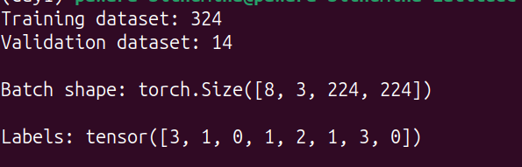

3. ImageNet normalization
ImageNet normalization uses mean values [0.485, 0.456, 0.406] and standard deviations [0.229, 0.224, 0.225] for the RGB channels. These values are commonly used with pretrained computer vision models trained on ImageNet. Using the same normalization helps maintain compatibility with such models.

4. Batch size 8 vs 64
Factor | Batch 8 | Batch 64
Memory | Lower | Higher
Speed | Usually lower throughput | Usually higher throughput
Gradient | More noisy | Smoother
Hardware requirement | Lower | Higher
Suitable for limited RAM/VRAM | Better | Less suitable

Experiment (use the actual output of batch_comparison.py):

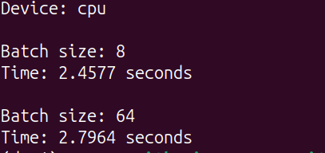

Task 8 — Ethics & Production

Ethical guidelines
- Obtain consent from people whose faces are collected.
- Store face data securely and restrict access.
- Delete the data when it is no longer required.

Failure scenarios
- Poor lighting or blurry images.
- Unknown person incorrectly classified as a known friend.
- Different pose, occlusion, or appearance causing recognition failure.

Production improvements
- Collect a larger and more diverse dataset.
- Use confidence thresholds so uncertain predictions can be rejected.
- Add security, monitoring and regular evaluation.

